Building our trail. Connecting our communities.
www.fireflytrail.com

February 21, 2022
Media Contact: Mark Ralston, 706.296.6717 / mralston@stmarysathens.org
Or John Kissane, 706.254.5474 / jakissane@gmail.com

Firefly Trail Ticket to Ride rolls again March 26

The 11th Annual Firefly Trail Ticket to Ride, presented by Athens Physical Therapy, returns Saturday, March 26, at 9 a.m. The non-competitive event will bring an estimated 300 cyclists to roads and towns from Athens to Union Point – or Union Point to Athens – to celebrate progress on the Firefly Trail and build momentum to connect the existing segments.

The ride will be held on paved roads and segments of trail on or close to the historic corridor of the Georgia Railroad Athens Branch. The route highlights completed stretches of the trail in Union Point, Maxeys, Winterville and Athens. Funds generated by Ticket to Ride are used by Firefly Trail Inc. to support its work to assist communities in building, promoting, and maintaining the trail.

When completed, the trail will provide a safe, off-road, 39-mile path for walking, running, cycling and other non-motorized uses through three counties and seven towns and cities. As rail-trails have done all over the U.S., it will improve health, create economic opportunities, promote equity and build a greater sense of community.

The Ticket to Ride is unique among area cycling events because it features out-and-back options up to 87 miles. Riders can tailor their ride to fit their riding style by simply turning around. Start/finish locations will be at Jittery Joe’s Roaster in Athens, the historic Depot in Winterville, and Union Point Theatre in Union Point. Riders are treated to beautiful countryside, friendly towns, and on-road vehicle support, with restrooms, snacks and beverages every 8-13 miles.

In addition, planning is in progress to welcome riders back to Athens and Union Point. At Jittery Joe’s Roaster, Rashe’s Cuisine food truck will provide Jamaican-inspired fare for purchase, and a variety of canned Creature Comforts beer will be available for purchase by those 21 and older with ID (one free can for registered riders). Union Point plans will be announced soon.

“It’s a lot of fun to support a great cause: building a major rail-trail to connect our communities with a safe, off-road path,” said Firefly Trail President Mark Ralston. “Because it flattens out most of the hills, the Firefly Trail can be enjoyed by everyone, regardless of age or physical ability.”

In addition, the Firefly Trail will connect to other trails for even greater opportunities, including the growing Greenway Network in Athens, Corry House/Hart Farms mountain bike trails in Union Point, and the proposed Georgia Hi-Lo Trail from Union Point to Savannah. It will also serve as an important connector in Oglethorpe and Greene counties for “gravel grinding,” an increasingly popular form of cycling that uses little-traveled unpaved roads.

Volunteers are vital to the event, and numerous opportunities are available. All volunteers receive a knit beanie. For information or to sign up, go to https://signup.com/go/QvpdJXt.

Pre-registration is now open on Active.com. Adults are $40 each, students are $30, and teams of 5-12 riders can pre-register as a group for $35 each. Ride-day registration will be $45 for adults and $30 for students. Riders will receive a knit beanie while supplies last. All proceeds from the event benefit Firefly Trail Inc., a 501(c)(3) organization dedicated to helping local communities build the Firefly Trail.

Because COVID-19 remains active in our region, this year’s ride will use “trickle-out” starts, hand sanitizer will be available at SAG stops, and drivers and riders will be asked to wear masks and keep a window or two rolled down anytime a participant is using a SAG vehicle. Other precautions may be implemented if conditions warrant.

Ride details follow and are also available at www.fireflytrail.com.

- Pre-registration is open on Active.com until 7 p.m. March 25. $40 adults/$30 students.
- In-person pre-registration and packet pick-up will be available at Georgia Cycle Sport, 1029 Baxter St., Athens, on Friday, March 25, from 3-6 p.m.
- Day-of registration will open at 8 a.m. at all three locations. $45 adults/$30 students.
- Riders may depart when ready between 8-9 a.m.
- SAG stops will open at 8:30 a.m. in Winterville, 9 a.m. in Athens and Union Point, and 9:30 a.m. in Maxeys and Crawford. SAG stops will close after the last rider passes through.
- Support services will end and the course will close at 4:30 p.m.
- The gate at Jittery Joe’s Roaster will be locked after 4:30 p.m. Riders who expect to return later should park in another location.
- Parking in Athens will be at Jittery Joe’s Roaster, 425 Barber St., until full. Overflow parking will be approximately 0.5 miles away at Athens Cotton Press, 149 Oneta St.
- Parking in Winterville will be in the Pittard Park overflow lot off Parkview Road.
- Parking in Union Point will be downtown near the Union Point Theatre, 101 Fluker St.
- Riders must be comfortable sharing the road with motor vehicles and sharing the trail with other cyclists and pedestrians.
- Helmets are required, and riders must obey all local and state laws.
- The speed limit on trail segments is 15 mph.
- Riders should not ride in pacelines on the trail.
- One-way distances are 7.7 miles from Athens to Winterville, 11.4 miles from Winterville to Crawford, 9.7 miles from Crawford to Maxeys, and 12.7 miles from Maxeys to Union Point.
- Knit beanies are guaranteed to riders who pre-register and to day-of registrants on a first-come, first-served basis while supplies last.
- Volunteers driving support vehicles will patrol the course to assist participants who are too tired to continue or have mechanical problems. SAG vehicles cannot be used as shuttles.

The pace of progress on the trail continues to be strong. Several segments are now open and will be used in the Ticket to Ride where possible:
- Athens-Clarke County – 2.6 miles, with another 3.5 miles in planning and acquisition. ACC is also building a bridge for the trail over Trail Creek
- Winterville – 1.4 miles
- Maxeys – 1.4 miles
- Union Point – 0.6 miles
- In partnership with the following cities and Firefly Trail Inc., Greene County has secured a $2.1 million Georgia Outdoor Stewardship Program grant to build up to 6 miles of trail in Greene County, Woodville, Union Point and Maxeys.

# # #

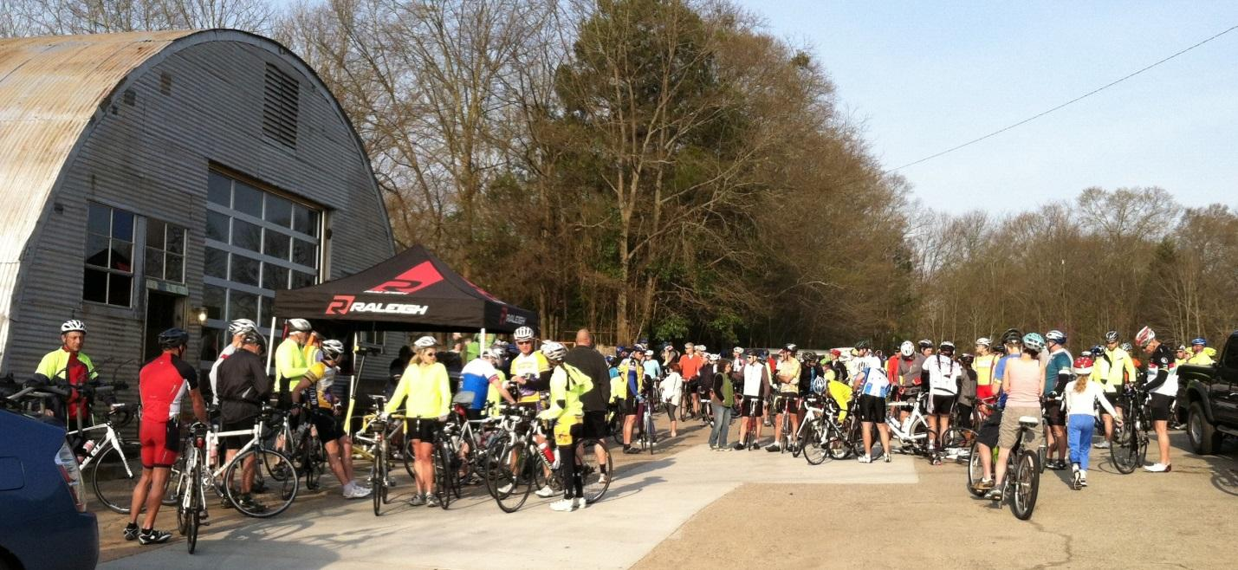
Riders gather at Jittery Joe's Roaster in Athens for the start of a past Firefly Trail Ticket to Ride. Close to 300 riders are expected at this year's event, with starting points in Athens, Winterville and Union Point. Music, food trucks and locally brewed beer will be available for returning riders from about 11 a.m. to 3 p.m.

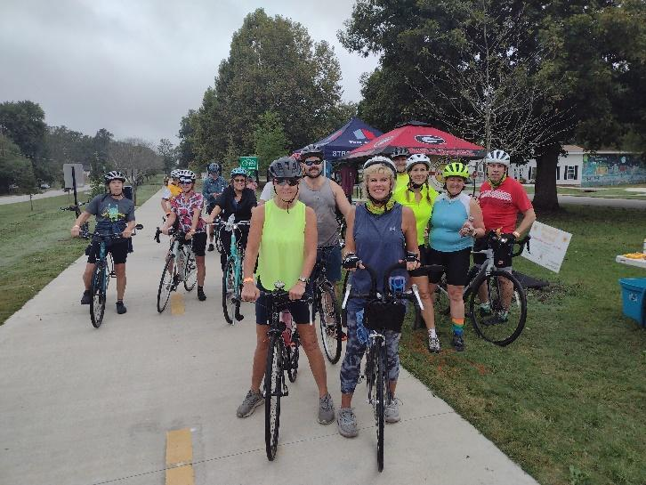
Riders in a past Firefly Trail Ticket to Ride prepare to leave the SAG stop at the Winterville Depot on the Firefly Trail. Winterville will again host a start/finish point and SAG stop at the Depot

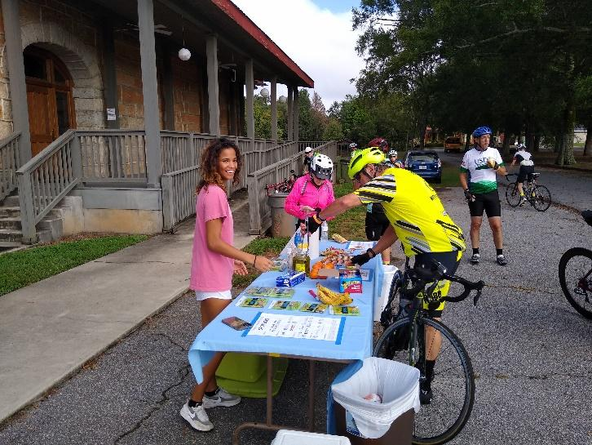
Riders and volunteers enjoy the SAG stop at the Crawford Depot. Crawford is the halfway point for riders starting in Athens or Union Point, and a great out-and-back option for those starting in Athens, Winterville or Union Point who want a shorter ride. Some even grab a quick lunch at nearby restaurants.

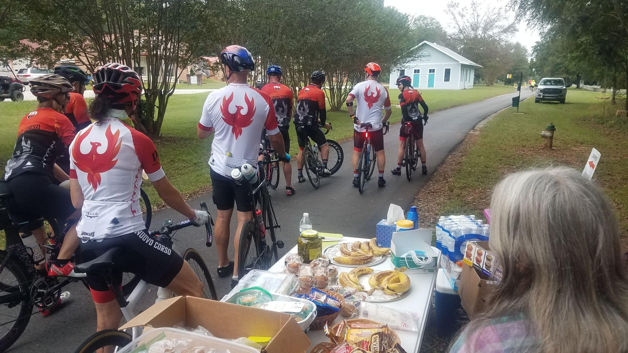
Firefly Trail Ticket to Ride riders enjoy the 2021 SAG stop on the trail just south of the historic Maxeys Depot. This year’s ride will again feature the newly completed 1.4-mile section of the Firefly Trail in Maxeys.

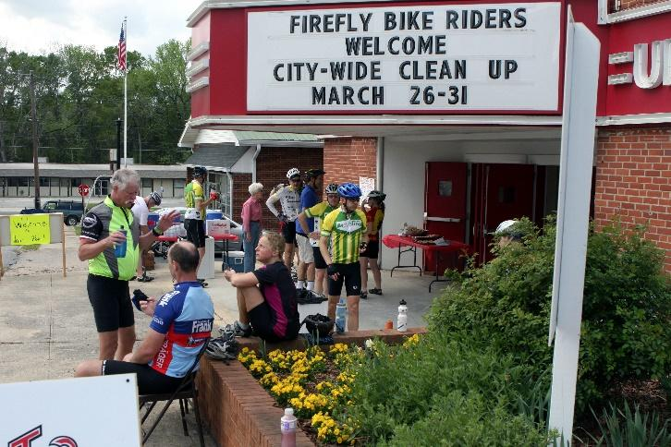
Firefly Trail Ticket to Ride participants enjoy a little rest, food and conversation in downtown Union Point during a past event. Union Point is again hosting a ride start and finish point, as well as a SAG stop at the Union Point Theatre.

